VISHNU INSTITUTE OF TECHNOLOGY
(AUTONOMOUS)
(APPROVED BY AICTE, ACCREDITED BY NBA & NAAC AND PERMANENTLY AFFILIATED TO JNTU KAKINADA)
BHIMAVARAM – 534202
2022 – 2023
DEPARTMENT OF INFORMATION TECHNOLOGY

COLLEGE MANAGEMENT USING DJANGO
A Mini Project submitted in partial fulfillment of the award of the degree of
BACHELOR OF TECHNOLOGY IN AI&ML
DBMS STUDENT MANAGEMENT SYSTEM:
Submitted by:
- B .Pradeep(21pa1a6104)
- A. Deepu(22pa5a6101)
- S. Lakshmi Sudhakar (22pa5a6105)
- K.Mani shankar (22pa5a6102)
V . V.charani (22pa5a6106)
Languages Used:
DBMS,DJANGO,PYTHON.
Under the esteemed guidance of
Mrs Venkata Naga Rani Bandaru
Assistant professor
Department of Information Technology
VISHNU INSTITUTE OF TECHNOLOGY
(Autonomous)
(Approved by AICTE, Accredited by NBA & NAAC and permanently affiliated to JNTU Kakinada)
BHIMAVARAM – 534202
2022 – 2023

DEPARTMENT OF INFORMATION TECHNOLOGY
CERTIFICATE
This is to certify that the project entitled “college management using django” , is being submitted by B.pradeep, k.manishankar , S.sudhakar AND A.Deepu,V.charani bearing REGD.NO’S : 21PA1A6104 , 22PA5A6101 , 22PA5A6102AND 22PA5A6105, 22PA5A6106 submitted in fulfillment for the award of the degree of “BACHELOR OF TECHNOLOGY” in “ARTIFICIAL INTELLEGENCE &MACHINE LEARNING” is a record of bonafide work carries out by them under my guidance and supervision during the academic year 2023- 2024 and it has been found worthy of acceptance according to the requirements of university.

Internal Guide : Head of the Department
Mrs Venkata Naga Rani Bandaru Mrs. M. Sri Lakshmi
Assistant Professor HOD & Professor

CONTENTS
S.NO. | TITLE
1. | Introduction of project
2. | Coding
3. | Output
4. | Conclusion

INTRODUCTION
Mini-project description – “COLLEGE MANAGEMENT USING DJANGO”
One of the simplest and useful application for knowing your age is ”college management”. User knowing how the bachelor age were be mention by an years . By using pre-defined module, compiler can get the present date and time too. Difference between the user’s idealogy to take an selection of category and present year gives the age of the user. But we also need to check the year of studing and days to calculate correct age in years, , to achieve this task we will check the difference between user’s and present year by their selection of course .

ALL files with directories:
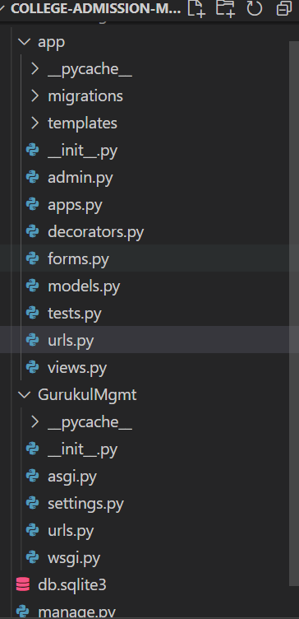

main.html:
<!DOCTYPE html>
<html lang="en">
<head>
<meta charset="UTF-8">
<meta name="viewport" content="width=device-width, initial-scale=1.0">
<link rel="stylesheet" href="https://stackpath.bootstrapcdn.com/bootstrap/4.5.0/css/bootstrap.min.css" integrity="sha384-9aIt2nRpC12Uk9gS9baDl411NQApFmC26EwAOH8WgZl5MYYxFfc+NcPb1dKGj7Sk" crossorigin="anonymous"0>
<title>ProjectGurukul College admission Mgmt Project</title>
</head>
<body>
{% include 'navbar.html' %}
<br>
<br>
{%block content%}
<div class="container">
<div class="row">
<div class="col-md">
<div class="card card-body">
<h5>Courses</h5>
</div>
<div class="card card-body">
<table class="table">
<tr>
<th>Course</th>
<th>Duration</th>
<th>fees</th>
</tr>
{% for i in courses %}
<tr>
<td>{{i.name}}</td>
<td>{{i.duration}} years</td>
<td>{{i.fees}}/-</td>
<td><a class="btn btn-success btn-sm" href="{% url 'description' i.id %}">View</a></td>
{% if request.user.is_authenticated %}
<td><a class="btn btn-danger btn-sm" href="{% url 'deleteCourse' i.id %}">Delete</a></td>
{% endif %}
</tr>
{% endfor %}
</table>
</div>
</div>
</div>
</div>
{% endblock %}

</body>
</html>

Admin.py:
from django.contrib import admin
from .models import *
# Register your models here.

admin.site.register(Courses)

Apps.py:
from django.apps import AppConfig

class AppConfig(AppConfig):
name = 'app'

from django.forms import ModelForm
from .models import *

class CourseForm(ModelForm):
class Meta:
model=Courses
fields="__all__"

Forms.py:
from django.db import models

# Create your models here.
class Courses(models.Model):
name=models.CharField(max_length=200,null=True)
duration=models.IntegerField(default=3,null=True,blank=True)
fees=models.IntegerField(null=True,blank=True)
decsription=models.CharField(null=True,blank=True,max_length=10000)
def __str__(self):
return str(self.name)

tests.py:
from django.test import TestCase

# Create your tests here.

url.py:
from django.urls import path
from .views import *
from django.contrib.auth import views as auth_views

urlpatterns = [
path('',home,name='home'),
path('createCourse/',createCourse,name='createCourse'),
path('description/<str:pk>',description,name='description'),
path('deleteCourse/<str:pk>/',deleteCourse,name='deleteCourse'),
path('register/', registerPage,name='register'),
path('login/', loginPage,name='login'),
path('logout/', logoutPage,name='logout'),
]

Views.py:
from django.shortcuts import render,redirect
from .models import *
from .forms import *
from django.contrib.auth.forms import UserCreationForm
from django.contrib.auth import login,logout,authenticate

# Create your views here.

def home(request):
courses=Courses.objects.all()
context={
'courses':courses,
}
return render(request,'main.html',context)

def createCourse(request):
if request.user.is_authenticated:
form=CourseForm()
if(request.method=='POST'):
form=CourseForm(request.POST)
if form.is_valid():
form.save()
return redirect('/')
context={'form':form}
return render(request,'createCourse.html',context)
else:
return redirect('home')

def deleteCourse(request,pk):
if request.user.is_authenticated:
course=Courses.objects.get(id=pk)
if(request.method=='POST'):
course.delete()
return redirect('/')
context={
'course':course,
}
return render(request,'delete.html',context)
else:
return redirect('home')

def description(request,pk):
course=Courses.objects.get(id=pk)
context={
'course':course,
}
return render(request,'description.html',context)

def registerPage(request):
if request.user.is_authenticated:
return redirect('home')
else:
form=UserCreationForm()
if request.method=='POST':
form=UserCreationForm(request.POST)
if form.is_valid():
form.save()
return redirect('login')
context={
'form':form
}
return render(request,'register.html',context)

def loginPage(request):
if request.user.is_authenticated:
return redirect('home')
else:
if request.method=="POST":
username=request.POST.get('username')
password=request.POST.get('password')
user=authenticate(request,username=username,password=password)
if user is not None:
login(request,user)
return redirect('home')
context={}
return render(request,'login.html',context)

def logoutPage(request):
logout(request)
return redirect('login')

asgi.py:
"""
ASGI config for GurukulMgmt project.

It exposes the ASGI callable as a module-level variable named ``application``.

For more information on this file, see
https://docs.djangoproject.com/en/3.0/howto/deployment/asgi/
"""

import os

from django.core.asgi import get_asgi_application

os.environ.setdefault('DJANGO_SETTINGS_MODULE', 'GurukulMgmt.settings')

application = get_asgi_application()

Settings.py:
"""
Django settings for GurukulMgmt project.

Generated by 'django-admin startproject' using Django 3.0.8.

For more information on this file, see
https://docs.djangoproject.com/en/3.0/topics/settings/

For the full list of settings and their values, see
https://docs.djangoproject.com/en/3.0/ref/settings/
"""

import os

# Build paths inside the project like this: os.path.join(BASE_DIR, ...)
BASE_DIR = os.path.dirname(os.path.dirname(os.path.abspath(__file__)))

# Quick-start development settings - unsuitable for production
# See https://docs.djangoproject.com/en/3.0/howto/deployment/checklist/

# SECURITY WARNING: keep the secret key used in production secret!
SECRET_KEY = 'n@z6b^56u6zbby-f7*am8)#np77t%p-zb67p^c66+qwo*-z0v*'

# SECURITY WARNING: don't run with debug turned on in production!
DEBUG = True

ALLOWED_HOSTS = []

# Application definition

INSTALLED_APPS = [
'django.contrib.admin',
'django.contrib.auth',
'django.contrib.contenttypes',
'django.contrib.sessions',
'django.contrib.messages',
'django.contrib.staticfiles',
'app.apps.AppConfig',
]

MIDDLEWARE = [
'django.middleware.security.SecurityMiddleware',
'django.contrib.sessions.middleware.SessionMiddleware',
'django.middleware.common.CommonMiddleware',
'django.middleware.csrf.CsrfViewMiddleware',
'django.contrib.auth.middleware.AuthenticationMiddleware',
'django.contrib.messages.middleware.MessageMiddleware',
'django.middleware.clickjacking.XFrameOptionsMiddleware',
]

ROOT_URLCONF = 'GurukulMgmt.urls'

TEMPLATES = [
{
'BACKEND': 'django.template.backends.django.DjangoTemplates',
'DIRS': [],
'APP_DIRS': True,
'OPTIONS': {
'context_processors': [
'django.template.context_processors.debug',
'django.template.context_processors.request',
'django.contrib.auth.context_processors.auth',
'django.contrib.messages.context_processors.messages',
],
},
},
]

WSGI_APPLICATION = 'GurukulMgmt.wsgi.application'

# Database
# https://docs.djangoproject.com/en/3.0/ref/settings/#databases

DATABASES = {
'default': {
'ENGINE': 'django.db.backends.sqlite3',
'NAME': os.path.join(BASE_DIR, 'db.sqlite3'),
}
}

# Password validation
# https://docs.djangoproject.com/en/3.0/ref/settings/#auth-password-validators

AUTH_PASSWORD_VALIDATORS = [
{
'NAME': 'django.contrib.auth.password_validation.UserAttributeSimilarityValidator',
},
{
'NAME': 'django.contrib.auth.password_validation.MinimumLengthValidator',
},
{
'NAME': 'django.contrib.auth.password_validation.CommonPasswordValidator',
},
{
'NAME': 'django.contrib.auth.password_validation.NumericPasswordValidator',
},
]

# Internationalization
# https://docs.djangoproject.com/en/3.0/topics/i18n/

LANGUAGE_CODE = 'en-us'

TIME_ZONE = 'UTC'

USE_I18N = True

USE_L10N = True

USE_TZ = True

# Static files (CSS, JavaScript, Images)
# https://docs.djangoproject.com/en/3.0/howto/static-files/

STATIC_URL = '/static/'

Urls.py
"""GurukulMgmt URL Configuration

The `urlpatterns` list routes URLs to views. For more information please see:
https://docs.djangoproject.com/en/3.0/topics/http/urls/
Examples:
Function views
1. Add an import: from my_app import views
2. Add a URL to urlpatterns: path('', views.home, name='home')
Class-based views
1. Add an import: from other_app.views import Home
2. Add a URL to urlpatterns: path('', Home.as_view(), name='home')
Including another URLconf
1. Import the include() function: from django.urls import include, path
2. Add a URL to urlpatterns: path('blog/', include('blog.urls'))
"""
from django.contrib import admin
from django.urls import path,include

urlpatterns = [
path('admin/', admin.site.urls),
path('',include('app.urls')),
]

Wsgi.py:
"""
WSGI config for GurukulMgmt project.

It exposes the WSGI callable as a module-level variable named ``application``.

For more information on this file, see
https://docs.djangoproject.com/en/3.0/howto/deployment/wsgi/
"""

import os

from django.core.wsgi import get_wsgi_application

os.environ.setdefault('DJANGO_SETTINGS_MODULE', 'GurukulMgmt.settings')

application = get_wsgi_application()

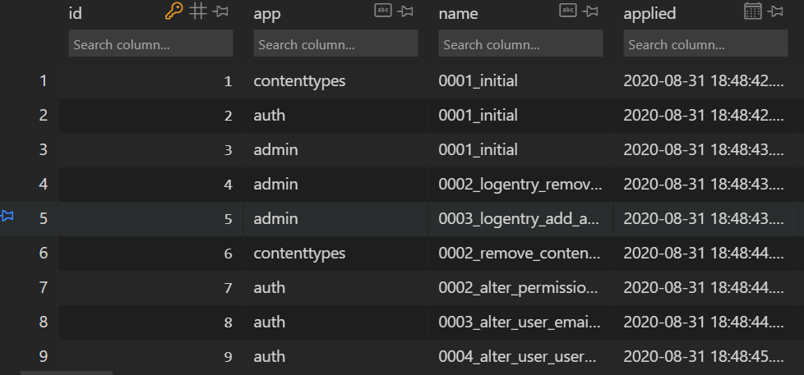

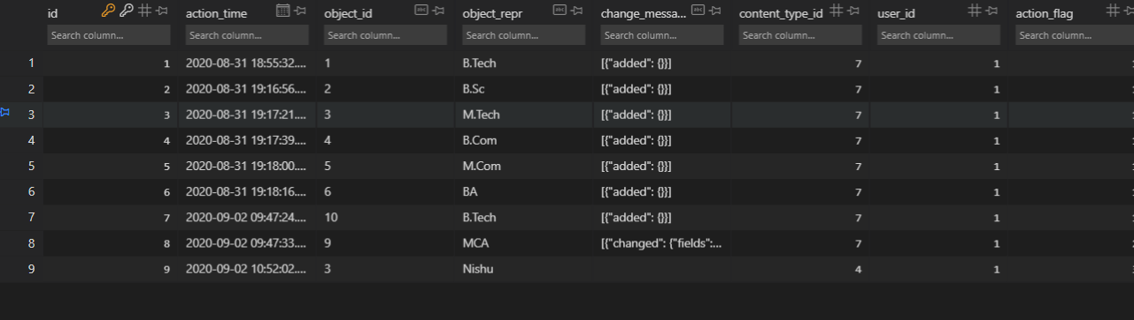
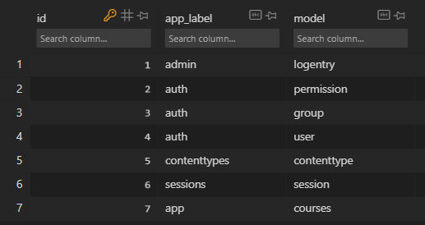
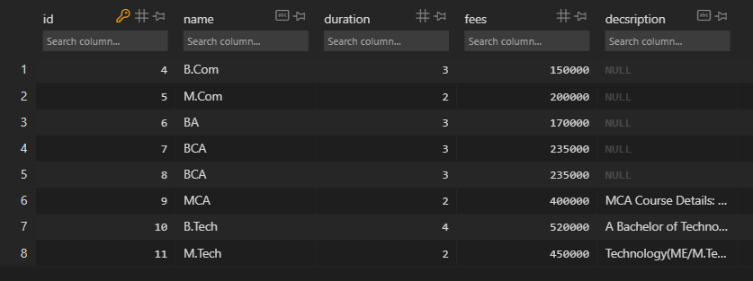
Manage.py:
#!/usr/bin/env python
"""Django's command-line utility for administrative tasks."""
import os
import sys

def main():
os.environ.setdefault('DJANGO_SETTINGS_MODULE', 'GurukulMgmt.settings')
try:
from django.core.management import execute_from_command_line
except ImportError as exc:
raise ImportError(
"Couldn't import Django. Are you sure it's installed and "
"available on your PYTHONPATH environment variable? Did you "
"forget to activate a virtual environment?"
) from exc
execute_from_command_line(sys.argv)

if __name__ == '__main__':
main()

OUTPUT:
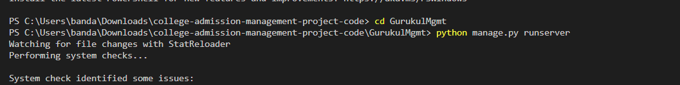
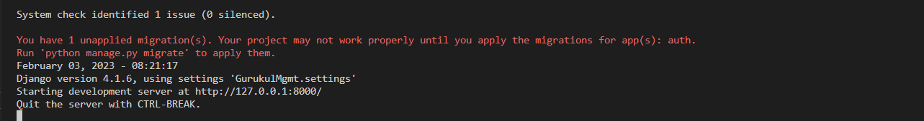

COLLEGE MANAGEMENT COURSES WITH AN DURATION &FEES:
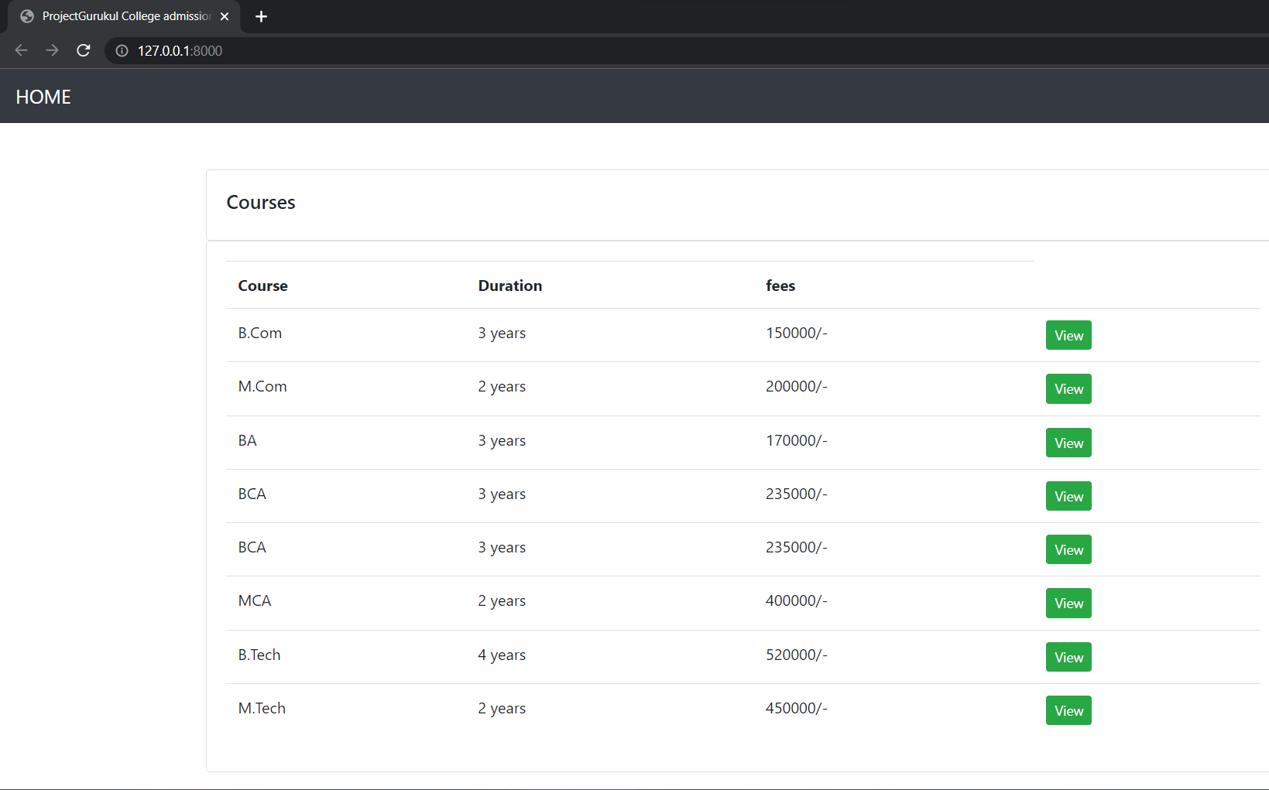

B.COM AND IT’S DETAILS OF COURES:
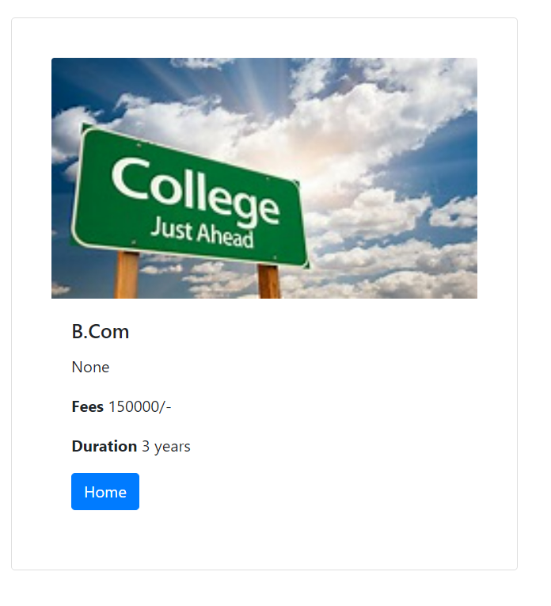

M.COM AND IT’S DETAILS OF COURES:
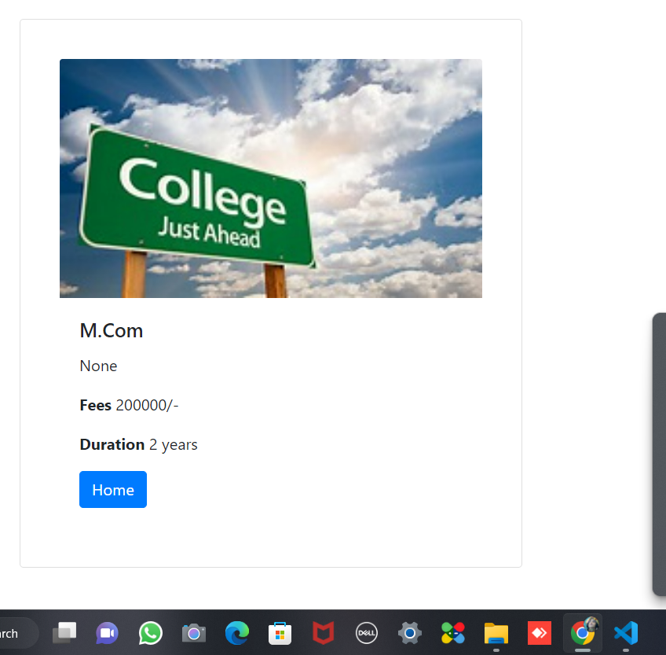

B.A AND IT’S DETAILS OF COURES:
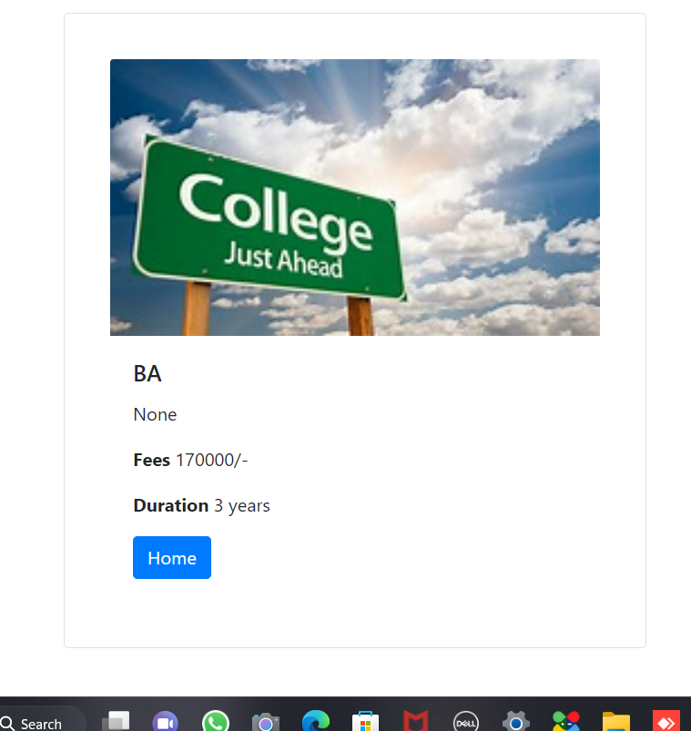

BCA AND IT’S COURSE DETAILS:
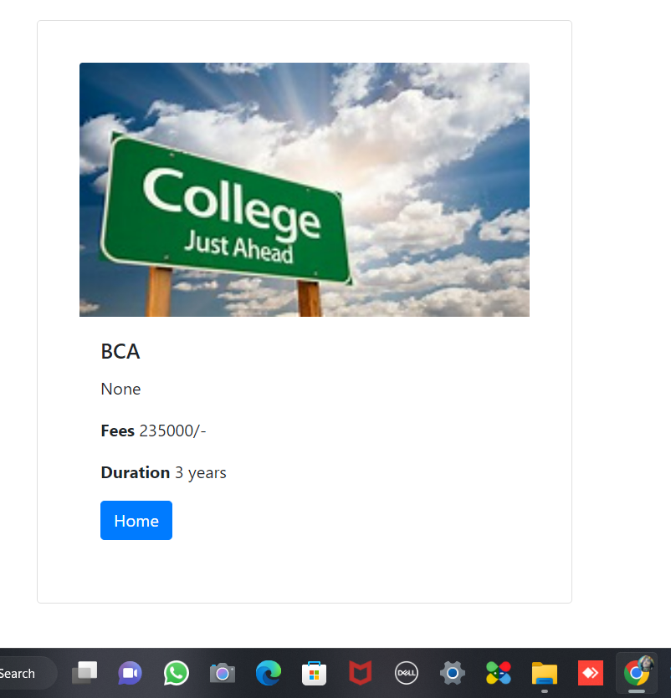

MCA AND IT’S COURSE DETAILS:


B.TECH AND IT’S FEE DETAILS :

M.TECH AND IT’S COURSE DETAILS:


